1. Find the Square root of a number in C++ using IF-ELSE statement?

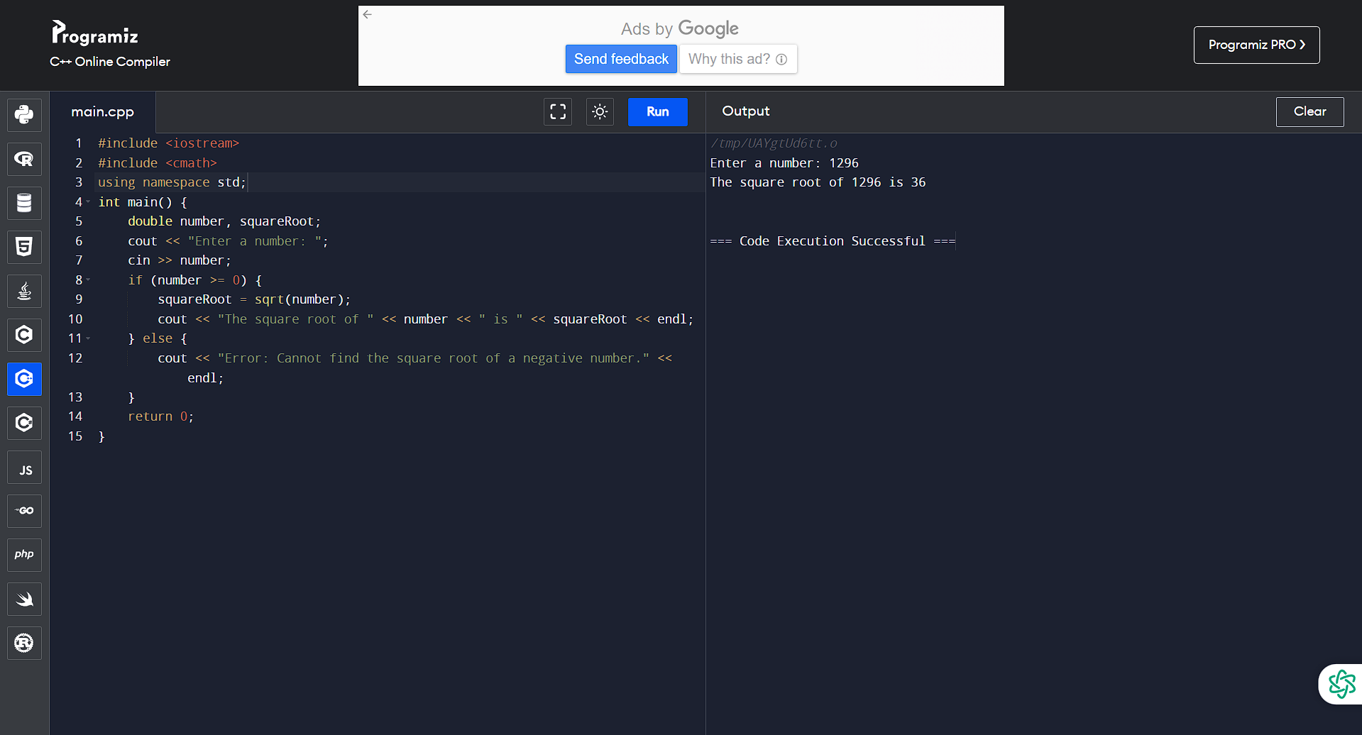

2. Find the Cube root of a number in in C++ using any conditional statements? 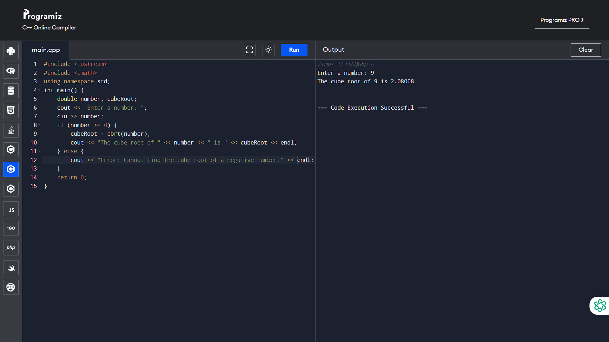

3. Write a C++ program to check if a number is perfect or not using IF condition? 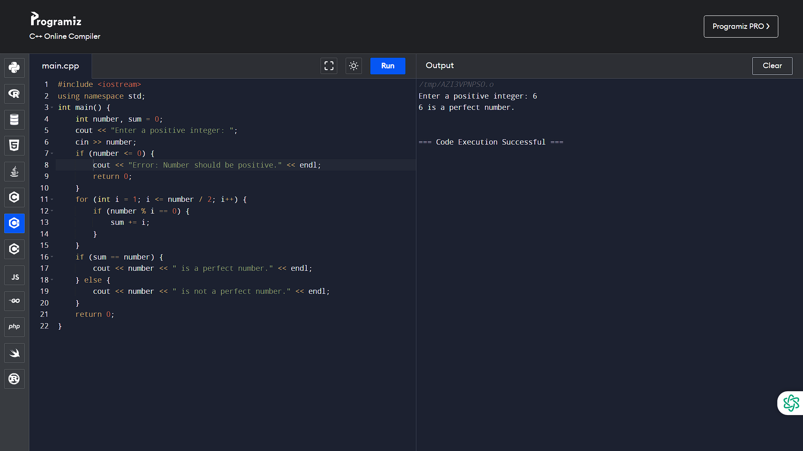

4. Write a C++ program to check if a number is perfect or not using IF-ELSE condition? 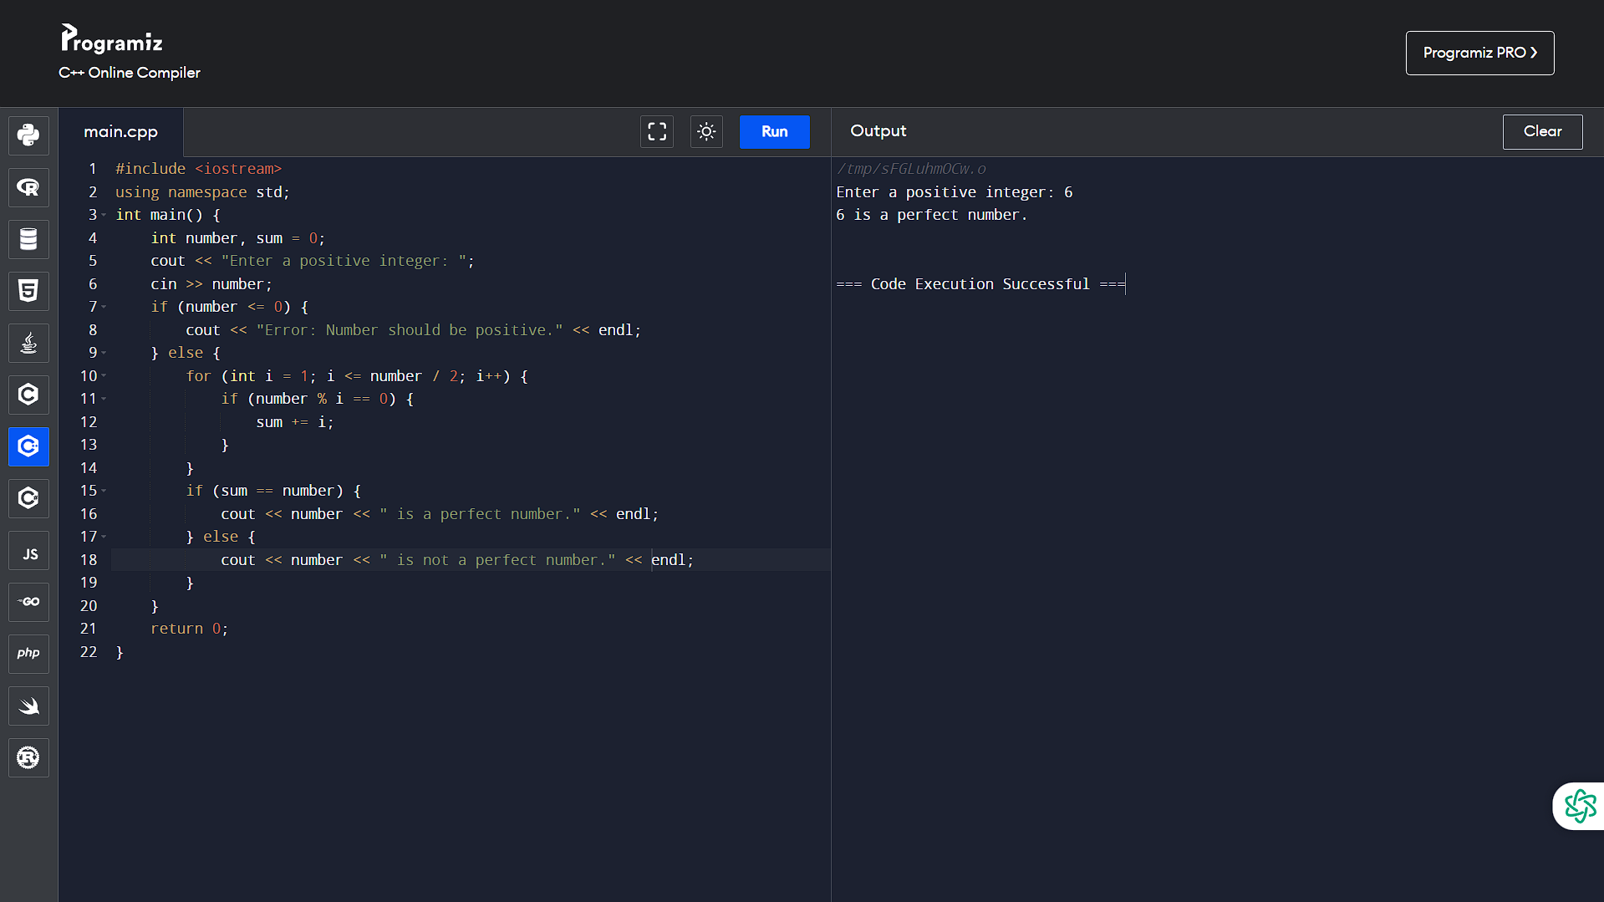

5. Write a C++ program to find the smallest element missing in a sorted array using WHILE loop?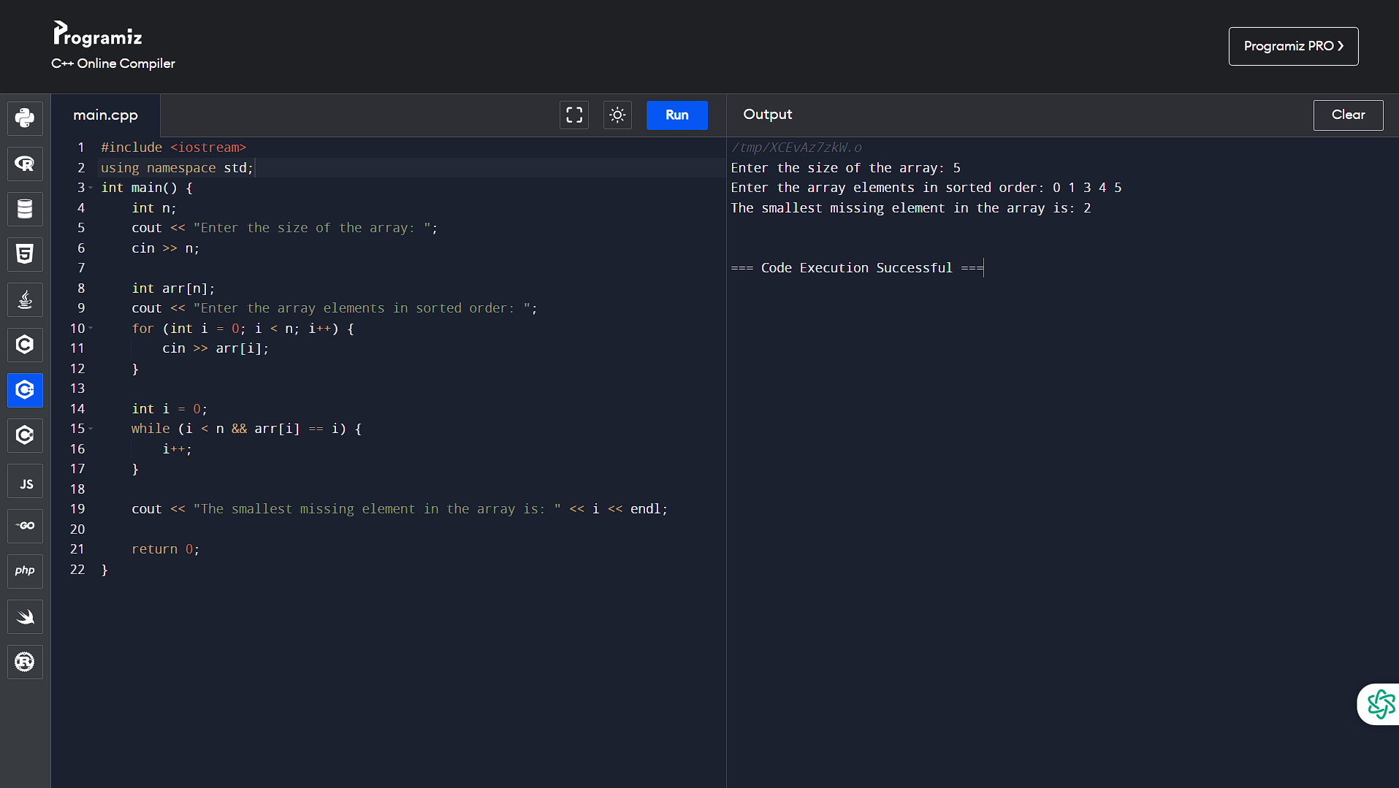

6. Write a program in C++ to find the sum of n natural numbers using FOR loop? 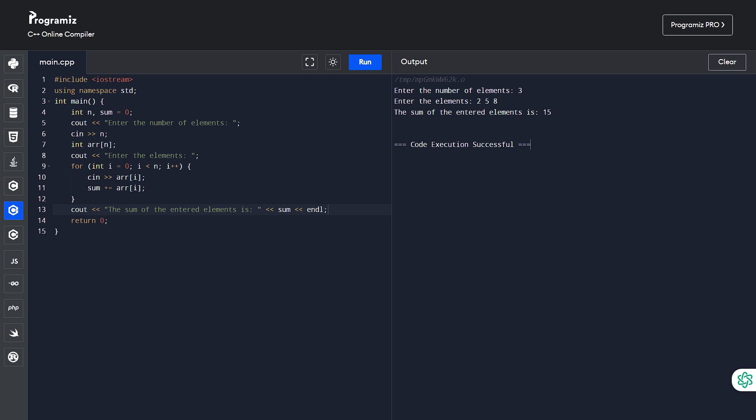

7. Write a program in C++ to find the sum of n natural numbers using WHILE loop? 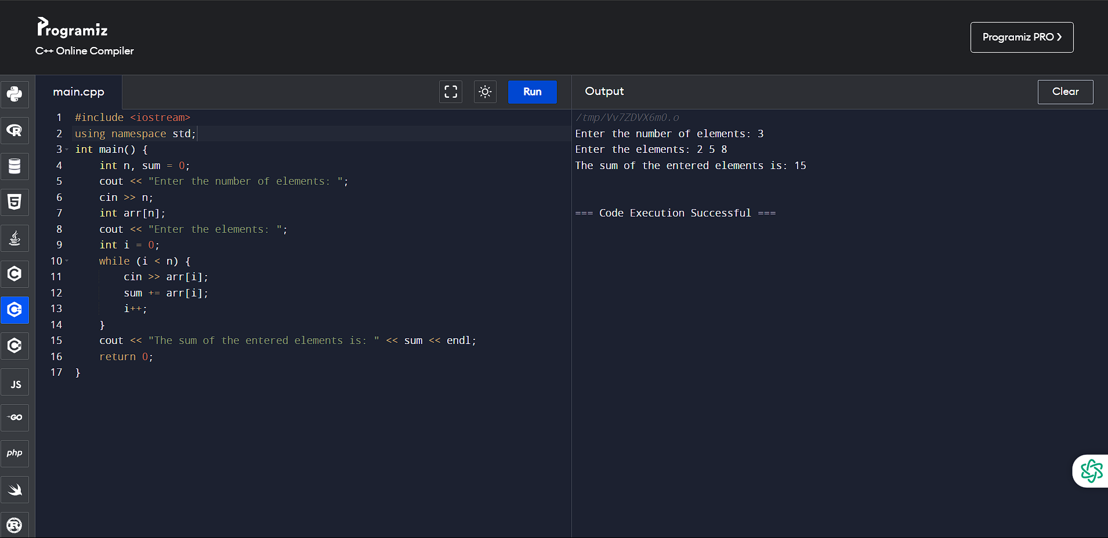

8. Write a program in C++ to find the sum of n natural numbers using DO WHILE loop? 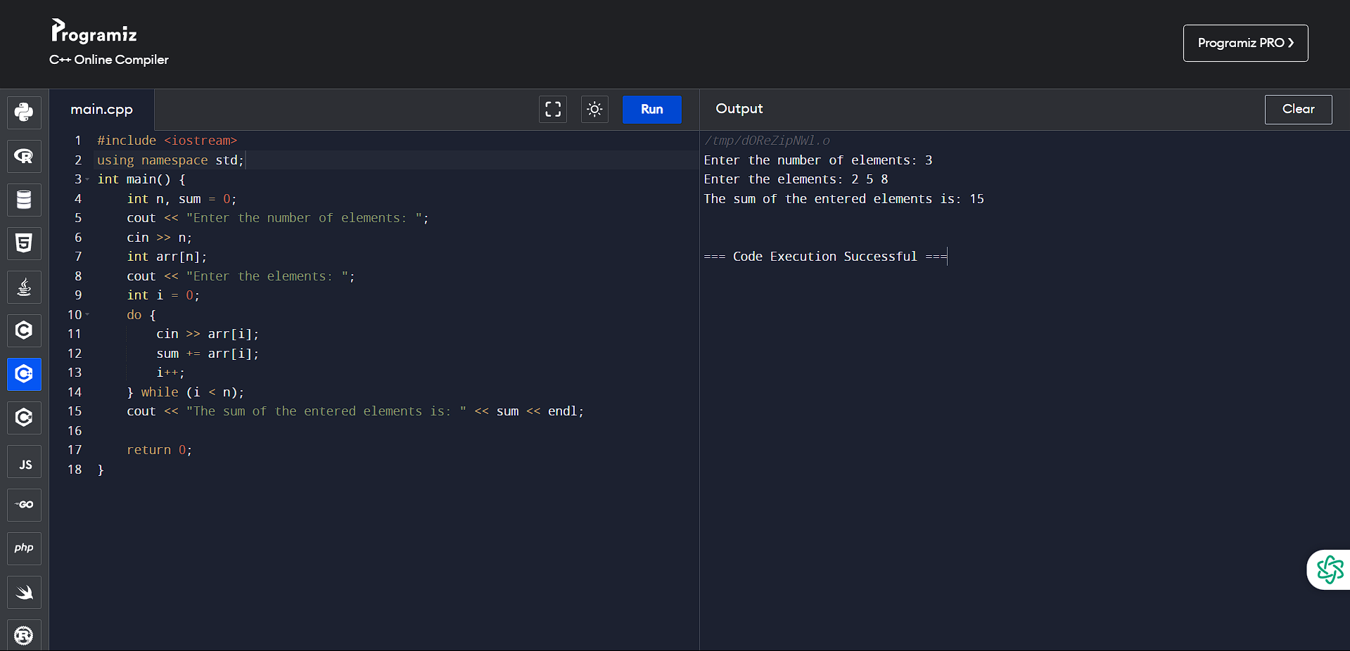

9. Write a C++ program to check if a number is perfect or not using FOR LOOP condition? 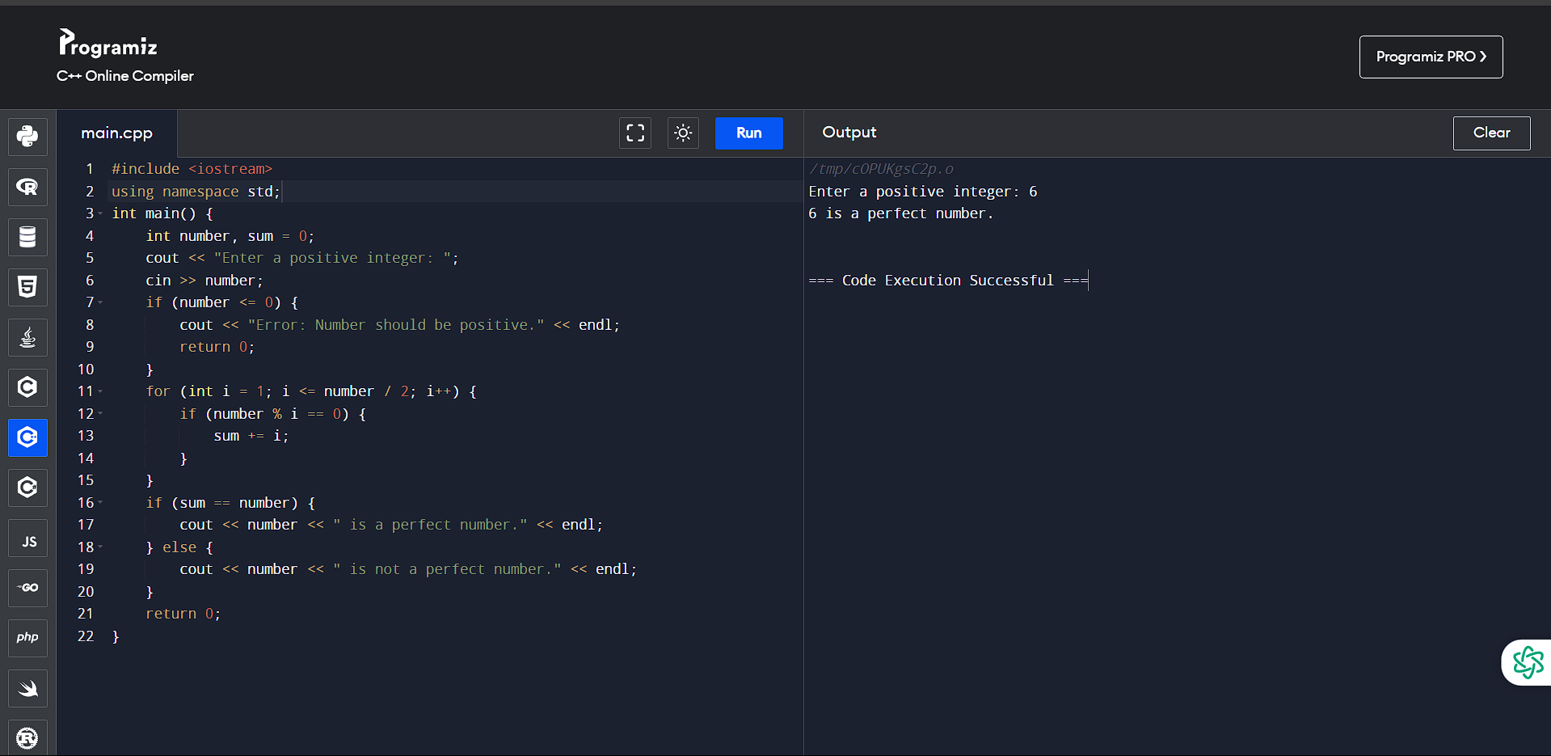

10. Write a C++ program to check if a number is perfect or not using WHILE condition? 